



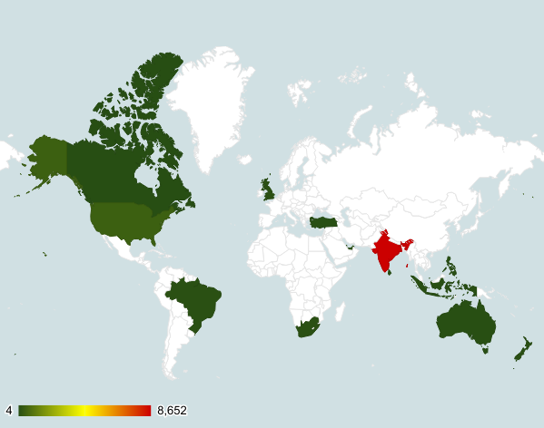

**Objective Questions**:

1. The data consists of some inconsistent and missing values so ensure that the data used for further analysis is cleaned.
2. Using the LookUp functions, fill up the countries in the original data using the country code.
3. Create a table to represent the number of restaurants opened in each country.
4. Also, the management wants to look at the number of restaurants opened in each year, so provide them with something here.
5. What is the total number of restaurants in India which are in the price range 4?
6. According to the data, what is the average number of voters for the restaurants in each country?

**ANSWERS:**

The dataset has been cleaned and few more columns have been added according to the need.

Excel File - [ZOMATO ANALYSIS](https://docs.google.com/spreadsheets/d/1xr3HAROs0LuXzLIh15SlujbPhb5CcwEGf6otE5NmUuw/edit?usp=sharing)

1. Worksheet - **Raw Data**
2. Worksheet - **Raw Data**

| *Country* | COUNT of RestaurantID |
| --- | --- |
| Canada | 4 |
| Qatar | 20 |
| Singapore | 20 |
| Sri Lanka | 20 |
| Indonesia | 21 |
| Philippines | 22 |
| Australia | 24 |
| Turkey | 34 |
| New Zealand | 40 |
| Brazil | 60 |
| South Africa | 60 |
| United Arab Emirates | 60 |
| United Kingdom | 80 |
| United States of America | 434 |
| India | 8652 |

| ***Country*** | **2010** | **2011** | **2012** | **2013** | **2014** | **2015** | **2016** | **2017** | **2018** |
| --- | --- | --- | --- | --- | --- | --- | --- | --- | --- |
| **Canada** |  | 1 |  | 1 |  | 1 |  | 1 |  |
| **Qatar** | 4 | 1 | 2 | 4 | 2 | 2 | 4 |  | 1 |
| **Singapore** | 2 | 3 | 4 | 1 | 2 | 2 | 1 | 2 | 3 |
| **Sri Lanka** | 1 | 2 | 3 | 4 | 2 | 3 | 2 | 2 | 1 |
| **Indonesia** | 1 | 5 |  | 1 | 4 | 3 | 1 | 1 | 5 |
| **Philippines** | 6 | 3 | 2 | 1 | 2 | 1 | 1 | 2 | 4 |
| **Australia** | 4 | 1 | 3 | 6 |  | 4 | 2 | 1 | 3 |
| **Turkey** | 3 | 2 | 1 | 5 | 6 | 4 | 4 | 3 | 6 |
| **New Zealand** | 4 | 6 | 4 | 2 | 4 | 4 | 4 | 5 | 7 |
| **Brazil** | 5 | 12 | 2 | 8 | 11 | 9 | 5 | 4 | 4 |
| **South Africa** | 4 | 4 | 7 | 8 | 5 | 7 | 10 | 9 | 6 |
| **United Arab Emirates** | 4 | 3 | 16 | 6 | 9 | 8 | 2 | 6 | 6 |
| **United Kingdom** | 9 | 6 | 12 | 10 | 11 | 5 | 7 | 12 | 8 |
| **United States of America** | 38 | 54 | 55 | 50 | 47 | 53 | 46 | 46 | 45 |
| **India** | 995 | 995 | 911 | 954 | 946 | 918 | 938 | 992 | 1003 |

| **COUNT OF RESTAURANT IN INDIA WITH 4 PRICE RANGE** | |
| --- | --- |
| **388** | |

1. 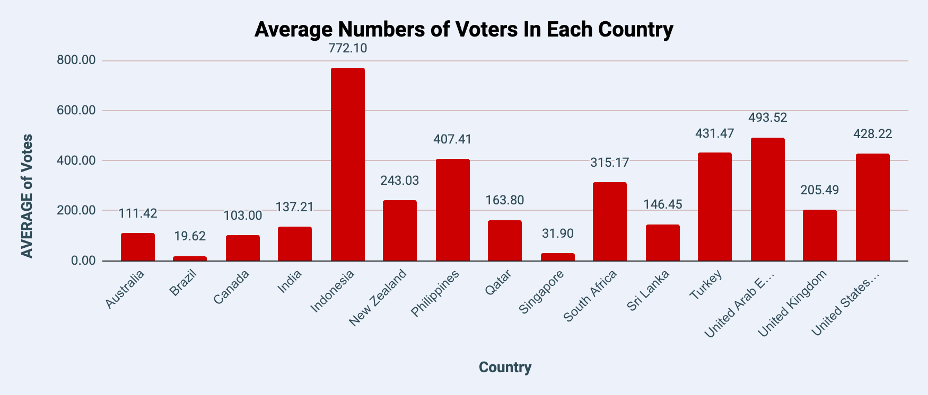

**Subjective Question:**

1. Suggest a few countries where the team can open newer restaurants with lesser competition. Which visualization/technique will you use here in order to justify the suggestions?
2. Come up with the names of States and cities in the suggested countries suitable for opening restaurants.
3. Name the chart/spreadsheet function you will use for solving the problem?
4. According to the countries you suggested, what is current quality in terms of ratings for restaurants that are opened there?
5. Will you use any aggregation function or a visualization here to solve the problem?
6. Also what is the current expenditure on the food in the suggested countries, so that we can keep our financial expenditure in control?
7. Mention the functionality which you will use for giving the suggestions, will it be any aggregated function or a visualization?
8. What is the distribution of number of restaurants of different price ranges in all the countries?
9. Distribution means the numbers of different price ranges, how will you show this using a chart?

**ANSWERS:**

1. According to the analysis in the following countries the team should open new restaurants, since the number of restaurants are less which decreases the competition:

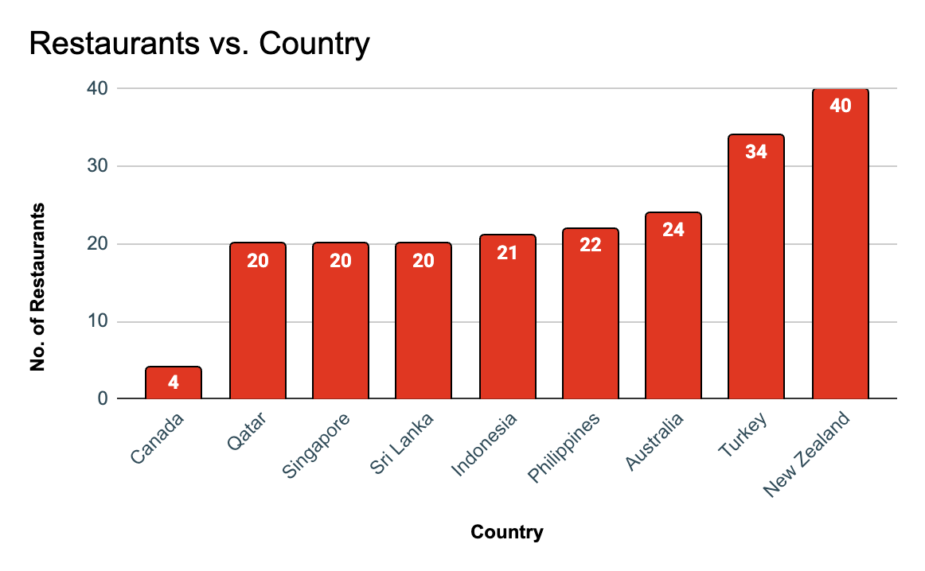

1. Following are the cities in each country where competition might be lesser in number as the count of restaurants in each city is lesser than the Median Count of Restaurants in all the cities in the data:

| **CITIES** | **COUNTRY** | **RESTAURANTS** |
| --- | --- | --- |
| Chatham-Kent | Canada | 1 |
| Consort | Canada | 1 |
| Vineland Station | Canada | 1 |
| Yorkton | Canada | 1 |
| Bandung | Indonesia | 1 |
| Bogor | Indonesia | 2 |
| Tangerang | Indonesia | 2 |
| Jakarta | Indonesia | 16 |
| Quezon City | Philippines | 1 |
| Tagaytay City | Philippines | 1 |
| Makati City | Philippines | 2 |
| San Juan City | Philippines | 2 |
| Santa Rosa | Philippines | 2 |
| Pasay City | Philippines | 3 |
| Pasig City | Philippines | 3 |
| Mandaluyong City | Philippines | 4 |
| Taguig City | Philippines | 4 |
| Armidale | Australia | 1 |
| Balingup | Australia | 1 |
| Beechworth | Australia | 1 |
| Dicky Beach | Australia | 1 |
| East Ballina | Australia | 1 |
| Flaxton | Australia | 1 |
| Forrest | Australia | 1 |
| Huskisson | Australia | 1 |
| Inverloch | Australia | 1 |
| Lakes Entrance | Australia | 1 |
| Lorn | Australia | 1 |
| Macedon | Australia | 1 |
| Mayfield | Australia | 1 |
| Middleton Beach | Australia | 1 |
| Montville | Australia | 1 |
| Palm Cove | Australia | 1 |
| Paynesville | Australia | 1 |
| Penola | Australia | 1 |
| Phillip Island | Australia | 1 |
| Tanunda | Australia | 1 |
| Trentham East | Australia | 1 |
| Victor Harbor | Australia | 1 |
| Hepburn Springs | Australia | 2 |
| ÛÁstanbul | Turkey | 14 |
| Randburg | South Africa | 1 |
| Inner City | South Africa | 2 |
| Johannesburg | South Africa | 6 |
| Sandton | South Africa | 11 |
| Clatskanie | United States of America | 1 |
| Cochrane | United States of America | 1 |
| Fernley | United States of America | 1 |
| Lakeview | United States of America | 1 |
| Lincoln | United States of America | 1 |
| Mc Millan | United States of America | 1 |
| Miller | United States of America | 1 |
| Monroe | United States of America | 1 |
| Ojo Caliente | United States of America | 1 |
| Potrero | United States of America | 1 |
| Princeton | United States of America | 1 |
| Vernonia | United States of America | 1 |
| Weirton | United States of America | 1 |
| Winchester Bay | United States of America | 1 |
| Mohali | India | 1 |
| Panchkula | India | 1 |
| Secunderabad | India | 2 |
| Chandigarh | India | 18 |
| Hyderabad | India | 18 |

* 1. First I created a Pivot table with all the Cities in each present country and used the aggregate function Count on RestaurantID to have the number of Restaurants in each city.

| *Country* | *City* | COUNT of RestaurantID |
| --- | --- | --- |
| Canada | Chatham-Kent | 1 |
| Canada | Consort | 1 |
| Canada | Vineland Station | 1 |
| Canada | Yorkton | 1 |
| Qatar | Doha | 20 |
| Singapore | Singapore | 20 |
| Sri Lanka | Colombo | 20 |
| Indonesia | Bandung | 1 |
| Indonesia | Bogor | 2 |
| Indonesia | Tangerang | 2 |
| Indonesia | Jakarta | 16 |
| Philippines | Quezon City | 1 |
| Philippines | Tagaytay City | 1 |
| Philippines | Makati City | 2 |
| Philippines | San Juan City | 2 |
| Philippines | Santa Rosa | 2 |
| Philippines | Pasay City | 3 |
| Philippines | Pasig City | 3 |
| Philippines | Mandaluyong City | 4 |
| Philippines | Taguig City | 4 |
| Australia | Armidale | 1 |
| Australia | Balingup | 1 |
| Australia | Beechworth | 1 |
| Australia | Dicky Beach | 1 |
| Australia | East Ballina | 1 |
| Australia | Flaxton | 1 |
| Australia | Forrest | 1 |
| Australia | Huskisson | 1 |
| Australia | Inverloch | 1 |
| Australia | Lakes Entrance | 1 |
| Australia | Lorn | 1 |
| Australia | Macedon | 1 |
| Australia | Mayfield | 1 |
| Australia | Middleton Beach | 1 |
| Australia | Montville | 1 |
| Australia | Palm Cove | 1 |
| Australia | Paynesville | 1 |
| Australia | Penola | 1 |
| Australia | Phillip Island | 1 |
| Australia | Tanunda | 1 |
| Australia | Trentham East | 1 |
| Australia | Victor Harbor | 1 |
| Australia | Hepburn Springs | 2 |
| Turkey | ÛÁstanbul | 14 |
| Turkey | Ankara | 20 |
| New Zealand | Auckland | 20 |
| New Zealand | Wellington City | 20 |
| Brazil | Brasí_lia | 20 |
| Brazil | Rio de Janeiro | 20 |
| Brazil | Sí£o Paulo | 20 |
| South Africa | Randburg | 1 |
| South Africa | Inner City | 2 |
| South Africa | Johannesburg | 6 |
| South Africa | Sandton | 11 |
| South Africa | Cape Town | 20 |
| South Africa | Pretoria | 20 |
| United Arab Emirates | Abu Dhabi | 20 |
| United Arab Emirates | Dubai | 20 |
| United Arab Emirates | Sharjah | 20 |
| United Kingdom | Birmingham | 20 |
| United Kingdom | Edinburgh | 20 |
| United Kingdom | London | 20 |
| United Kingdom | Manchester | 20 |
| United States of America | Clatskanie | 1 |
| United States of America | Cochrane | 1 |
| United States of America | Fernley | 1 |
| United States of America | Lakeview | 1 |
| United States of America | Lincoln | 1 |
| United States of America | Mc Millan | 1 |
| United States of America | Miller | 1 |
| United States of America | Monroe | 1 |
| United States of America | Ojo Caliente | 1 |
| United States of America | Potrero | 1 |
| United States of America | Princeton | 1 |
| United States of America | Vernonia | 1 |
| United States of America | Weirton | 1 |
| United States of America | Winchester Bay | 1 |
| United States of America | Albany | 20 |
| United States of America | Athens | 20 |
| United States of America | Augusta | 20 |
| United States of America | Boise | 20 |
| United States of America | Cedar Rapids/Iowa City | 20 |
| United States of America | Columbus | 20 |
| United States of America | Dalton | 20 |
| United States of America | Davenport | 20 |
| United States of America | Des Moines | 20 |
| United States of America | Dubuque | 20 |
| United States of America | Gainesville | 20 |
| United States of America | Macon | 20 |
| United States of America | Orlando | 20 |
| United States of America | Pensacola | 20 |
| United States of America | Pocatello | 20 |
| United States of America | Rest of Hawaii | 20 |
| United States of America | Savannah | 20 |
| United States of America | Sioux City | 20 |
| United States of America | Tampa Bay | 20 |
| United States of America | Valdosta | 20 |
| United States of America | Waterloo | 20 |
| India | Mohali | 1 |
| India | Panchkula | 1 |
| India | Secunderabad | 2 |
| India | Chandigarh | 18 |
| India | Hyderabad | 18 |
| India | Agra | 20 |
| India | Allahabad | 20 |
| India | Aurangabad | 20 |
| India | Bangalore | 20 |
| India | Bhopal | 20 |
| India | Chennai | 20 |
| India | Coimbatore | 20 |
| India | Dehradun | 20 |
| India | Goa | 20 |
| India | Indore | 20 |
| India | Jaipur | 20 |
| India | Kanpur | 20 |
| India | Kochi | 20 |
| India | Kolkata | 20 |
| India | Ludhiana | 20 |
| India | Mangalore | 20 |
| India | Mumbai | 20 |
| India | Mysore | 20 |
| India | Nagpur | 20 |
| India | Nashik | 20 |
| India | Patna | 20 |
| India | Puducherry | 20 |
| India | Pune | 20 |
| India | Ranchi | 20 |
| India | Surat | 20 |
| India | Vadodara | 20 |
| India | Varanasi | 20 |
| India | Vizag | 20 |
| India | Ahmedabad | 21 |
| India | Amritsar | 21 |
| India | Bhubaneshwar | 21 |
| India | Guwahati | 21 |
| India | Lucknow | 21 |
| India | Ghaziabad | 25 |
| India | Faridabad | 251 |
| India | Noida | 1080 |
| India | Gurgaon | 1118 |
| India | New Delhi | 5473 |

* 1. Then I created another table consisting of cities with count of restaurants lesser than the median count of restaurants in the whole data present using the following formulae:
     1. **City ->** ArrayFormula(IF('Country Wise Analysis'!N3:N143<MEDIAN('Country Wise Analysis'!N3:N143),'Country Wise Analysis'!M3:M143,""))
     2. **Country ->** XLOOKUP(G18,'Country Wise Analysis'!M$2:M$143,'Country Wise Analysis'!L$2:L$143)
     3. **Count of Restaurants ->** XLOOKUP(G18,'Country Wise Analysis'!M$2:M$143,'Country Wise Analysis'!N$2:N$143)

| **Country** | **Median Rating** |
| --- | --- |
| Canada | 3.5 |
| Qatar | 4 |
| Singapore | 3.75 |
| Sri Lanka | 4 |
| Indonesia | 4.3 |
| Philippines | 4.5 |
| Australia | 3.7 |
| Turkey | 4.3 |
| New Zealand | 4.3 |

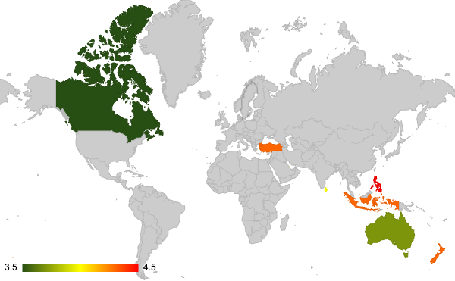

1. I used both an aggregation function using a pivot table which calculated the median rating grouped by country and a visualization using Geo Graph which clearly shows the rating distribution over countries.

| **Country** | **Average Cost for 2** |
| --- | --- |
| Canada | 36 |
| Qatar | 224 |
| Singapore | 156 |
| Sri Lanka | 2375 |
| Indonesia | 281190 |
| New Zealand | 70 |

1. I used pivot table aggregation functions to extract the average cost for 2 in each country then extracted the selected countries data using LOOKUP Function.

| *COUNT of RestaurantID* | *Average_Cost_for_two_Range* |  |  |  |  |  |
| --- | --- | --- | --- | --- | --- | --- |
| *Country* | >1000 | 0 - 100 | 100 - 250 | 250 - 500 | 500 - 1000 | Grand Total |
| Australia |  | 23 | 1 |  |  | 24 |
| Brazil |  | 25 | 26 | 9 |  | 60 |
| Canada |  | 4 |  |  |  | 4 |
| India | 1398 | 33 | 1365 | 2957 | 2899 | 8652 |
| Indonesia | 21 |  |  |  |  | 21 |
| New Zealand |  | 33 | 7 |  |  | 40 |
| Philippines | 15 |  |  |  | 7 | 22 |
| Qatar |  | 4 | 8 | 6 | 2 | 20 |
| Singapore |  | 12 | 2 | 5 | 1 | 20 |
| South Africa | 2 |  | 9 | 40 | 9 | 60 |
| Sri Lanka | 20 |  |  |  |  | 20 |
| Turkey |  | 25 | 8 | 1 |  | 34 |
| United Arab Emirates |  | 18 | 27 | 12 | 3 | 60 |
| United Kingdom |  | 73 | 7 |  |  | 80 |
| United States of America |  | 433 | 1 |  |  | 434 |
| **Grand Total** | **1456** | **683** | **1461** | **3030** | **2921** | **9551** |

1. Since the difference between values was alot therefore I used a 100% Stacked-Up Column Chart so that the comparison could be made and the visualisation works in-line with the problem.

